PROJECT REPORT

**DEVELOPING A BACKEND ADMIN FOR LEARNER’S ACADEMY**

Submitted in partial fulfillment of the requirement for the award of degree

OF

**FULL STACK JAVA DEVELOPER**

**PHASE-4 SESSION (16.01.2021-31.01.2021**)

**UNDER THE GUIDENCE OF**

**MRS. BHAWNA GUNWANI**

**COURSE INSTRUCTOR (SIMPLILEARN)**

**SUBMITTED BY**

**MANISH KUMAR ARORA**



**AT STUDY CENTRE**

**Learning Management System**

**SIMPLILEARN**

**CONTENTS**

1. Introduction
   1. Project Details
   2. Developer Details
   3. Problem Description
2. Sprint Plan
   1. Number of Sprints
   2. Duration of Sprint
   3. User Stories
   4. Task achieved in each Sprint
3. Algorithm of application
4. Flow Charts of application
5. Implementation
   1. Software and Tools used
   2. Methodology
   3. Coding
6. Output Test - Output Screens
7. Core Concept used in the Project
8. Links to the GitHub repository to track and verify the project
9. Conclusion
   1. Summary
   2. Future Enhancements
   3. Unique Selling Points(USPs)

**INTRODUCTION**

1. **Project Detail:**

The project “**Online Test Application**” aims to increase the scope of user’s interactions by developing dynamic web pages and menu driven options in order to create an application that enables users to provide online tests, review them, and display the results. The quiz application accepts the questions in JSON format. So, you can easily send the JSON from the server in the pre-defined format and the Angular quiz application will render the quiz at the client side. Once the questions are loaded, user can answer the questions and the events are being captured by the same component. When user finally submits the quiz, you may submit the answers to the server in JSON format. Or load the questions with answers and evaluate the users’ answers to show the quiz result immediately.

1. **Developer Detail:**

Manish Kumar Arora

Technical Support Associate, Engineering

MBA-IT, B.TECH-CSE

1. **Problem Description:**

This system contains three main modules: Quiz, Review, and Result. The quiz section of the online test application accepts the questions in JSON format. The JSON file can be easily shared from the server in the pre-defined format. The application renders the test at the client-side.

The “Review and display result” section allows users to declare the results immediately. We can simply call another JSON with the answers in it and evaluate and display the results immediately.

**SPRINT PLAN**

1. **Number of Sprints: 1**
2. **Duration of each sprint: One Week**
3. **User Stories: 4 user stories.**

Sprint1: 24.01.2021 – 31.01.2021

User Story1:

**Title: Quiz View**

**Priority: 1**

**Estimate: 3 D**

**As an** End User

**I want to** have an online quiz page

**So that I can** select the quiz type and select the multiple answers

User Story2:

**Title: Review**

**Priority: 2**

**Estimate: 2 D**

**As an** End User

**I want to** have review button

**So that I can** review the number of questions answered or not answered.

User Story3:

**Title: Result**

**Priority: 1**

**Estimate: 1 D**

**As an** End User

**I want to** have submit button.

**So that I can** submit the quiz and see the answers.

User Story4:

**Title: Timer**

**Priority: 1**

**Estimate: 1 D**

**As an** End User

**I want to** timer.

**So that I can** within specified time to test my efficiency.

1. **Task achieved in each sprint:**
2. **Sprint One – Developed interactive Quiz page, for first three tasks i.e. to view Quiz and the quiz type, Review the quiz for unanswered questions and Submit on completion of quiz. There will be an additional feature to include timer so that one can finish the quiz within that time limit.**

**Detailed Screenshots for each user stories used in scrum planning in each sprint:**

**Sprint 1: Date: 24.01.2021 – 31.01.2021**

1. **24.01.2021 – Quiz view page display work starts:**

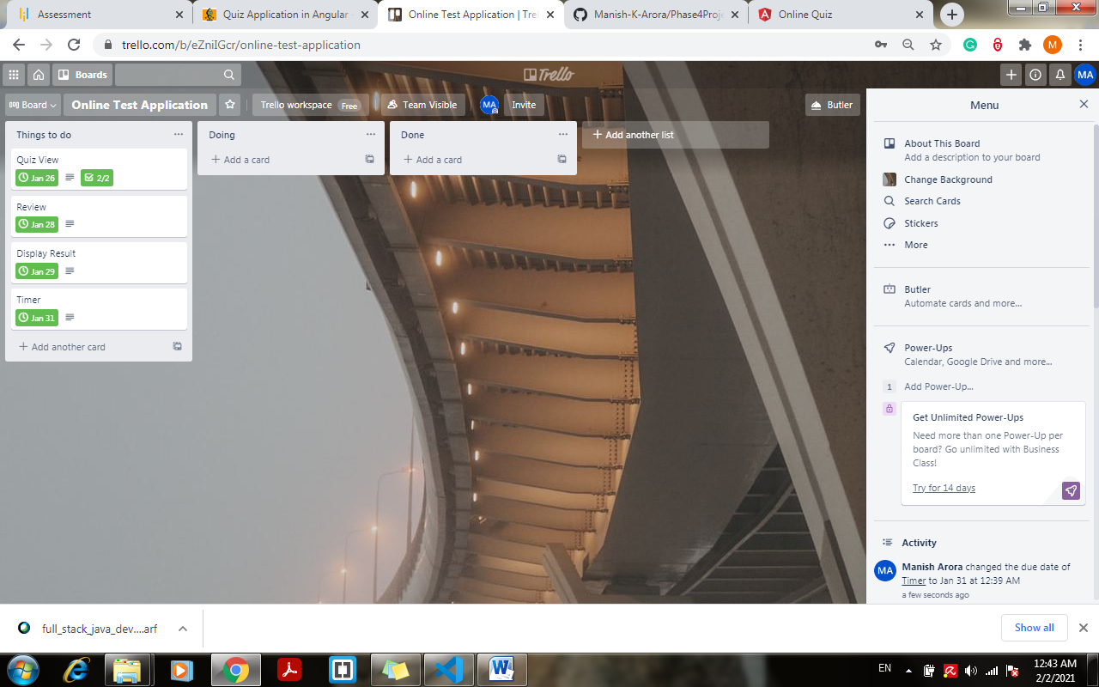

1. **26.01.2021 – Quiz view page display work completed:**

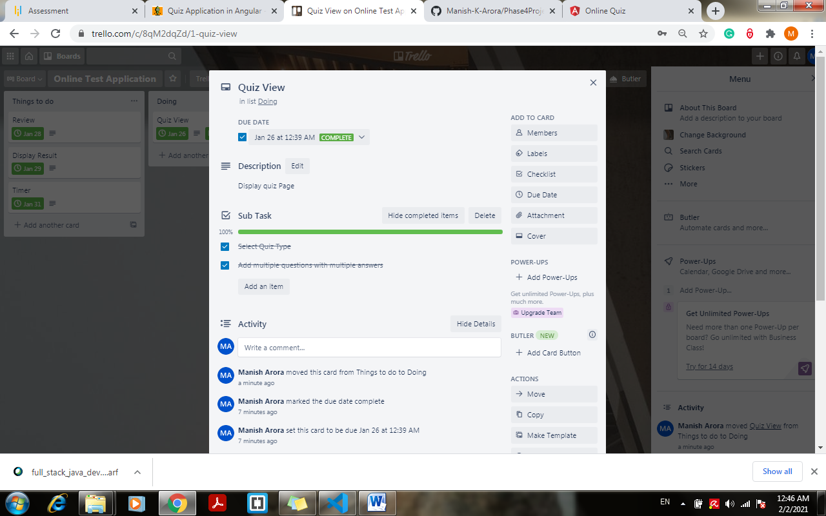 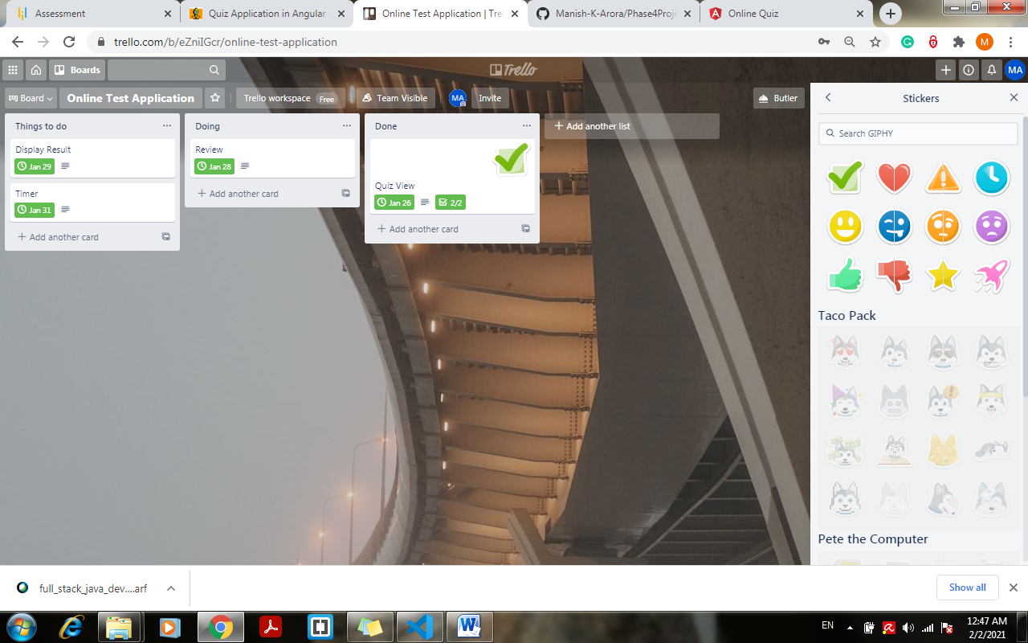

1. **27.01.2021 – Review component work starts:**

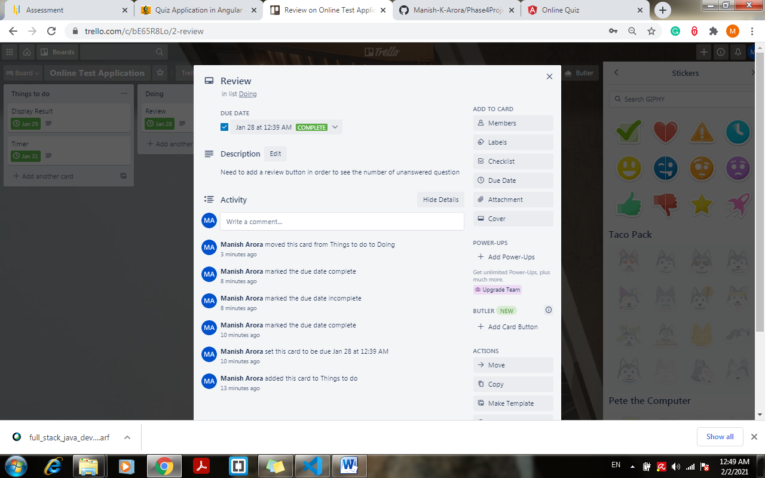

1. **28.01.2021 – Review component work completed:**

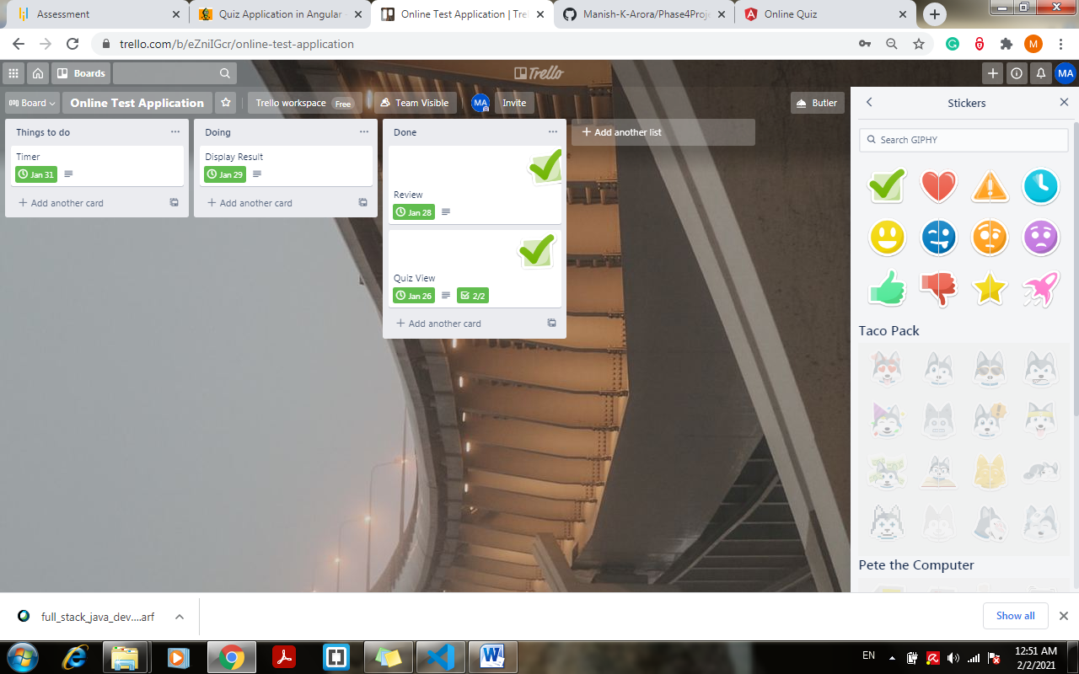

1. **29.01.2021 – Display component work starts and completed:**

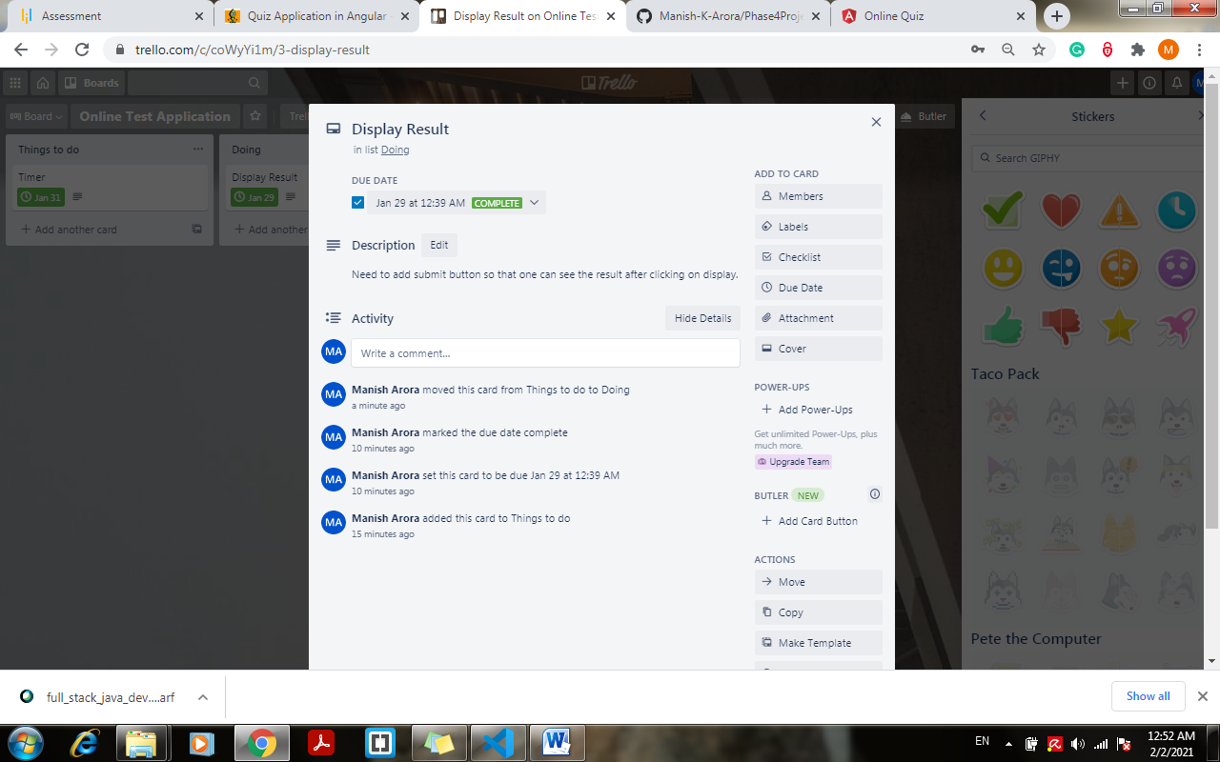

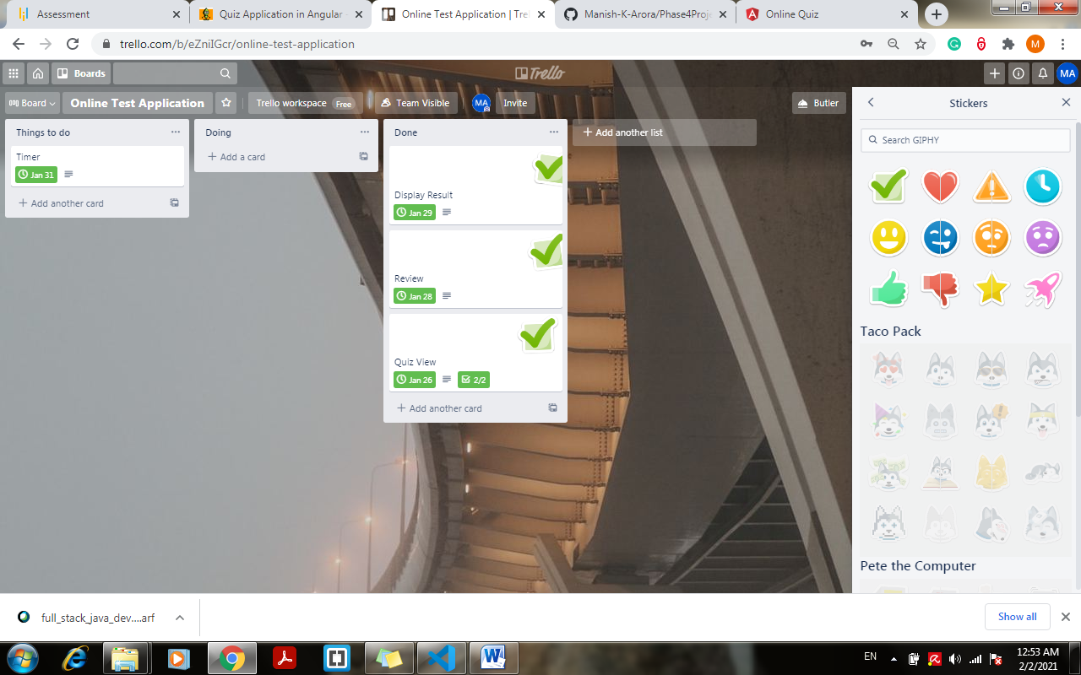

1. **30/31.01.2021 – Timer added to the quiz app:**

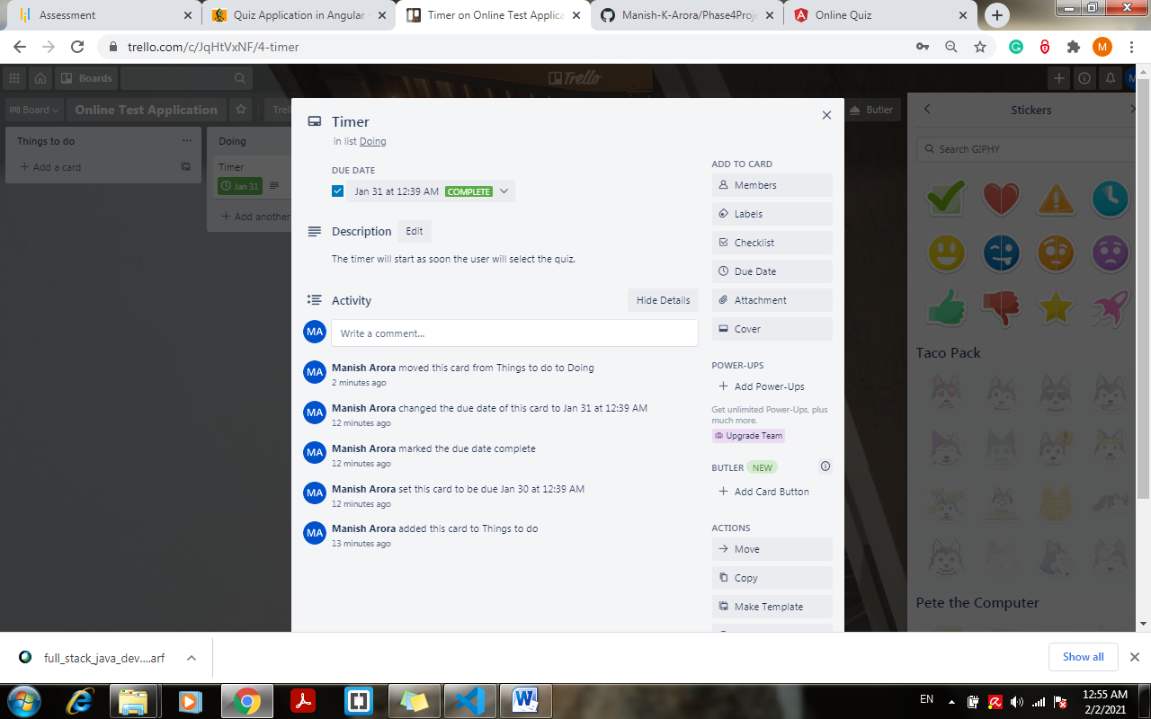

Sprint 1– Completed Date: 31.01.2021

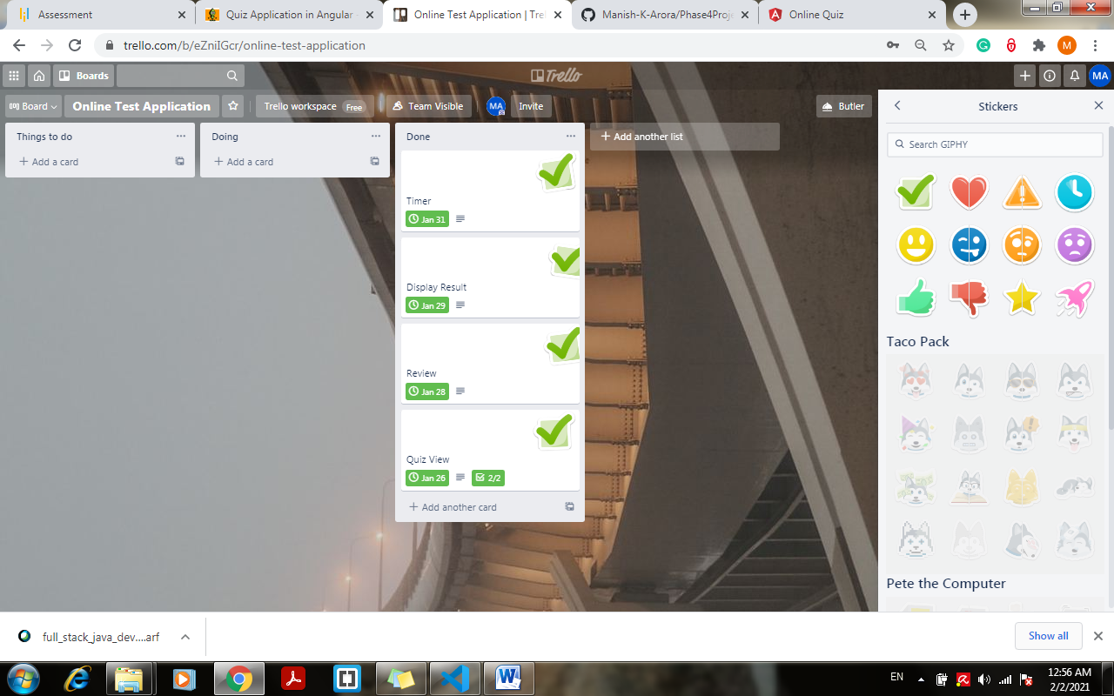

**ALGORITHM OF APPLICATION**

1. **On first run> checks angular.json**
2. **Looks for index property > src/index.html**
3. **Goto:: index.html > check the component**
4. **Goback -> angular.json > check main property > src/main.ts**
5. **Goto:: main.ts -> check the bootstrap module**
6. **Goto:: app.module -> check the bootstrap component**
7. **Goto :: root component and check the selector**
8. **If the selector matcher -> render the html template**
9. **Display quiz**
10. **If User selects - > Angular -> timer starts**
11. **Call - > Angular.json - > display angular quiz**
12. **If user selects - > JSON**
13. **Call -> Json.json -> display json quiz -> timer starts**
14. **If click Review -> Display unanswered question**
15. **If Click Submit - > display result.**
16. **If timer stops -> automatically submit and display results**

**FLOWCHART OF APPLICATION**

**USE CASE DIAGRAM**

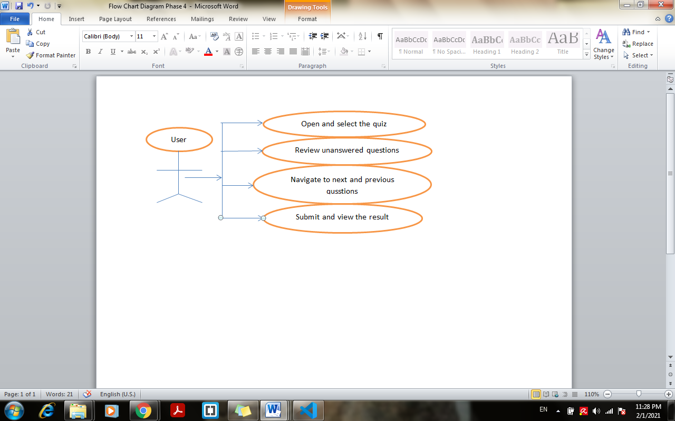

**Flow Chart 1:**

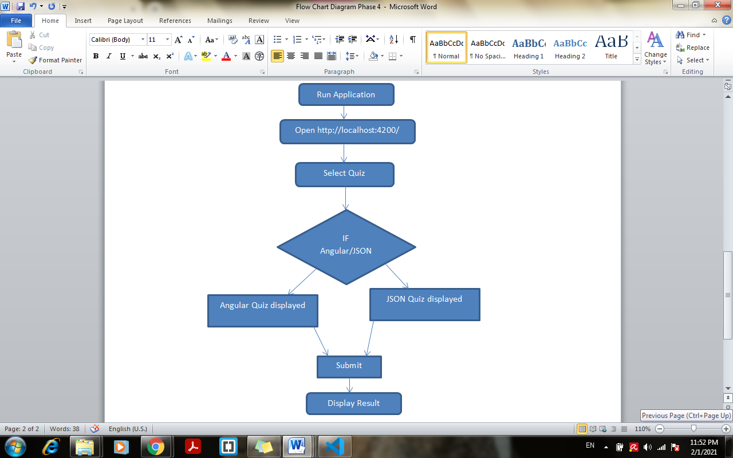

**IMPLEMENTATION**

1. **Software and Tools used: This is Angular Web Project.**
2. Operating System - Windows 7 or upper version
3. Visual Studio Code- To write JavaScript or Typescript code JSON code for application
4. Trello – Online web app for sprint planning and make user cards.
5. Bootstrap and CSS – for designing the Quiz page
6. GitHub – Online repository to track and submit the project
7. MS-Word – To create user stories and flow chart
8. **Methodology: Agile-Scrum**
9. **Coding: Just provide the JSON to the quiz application and it will render the quiz**
10. **Code for angular quiz- “angular.json”**

{

    "id": 1,

    "name": "Angular Online Quiz",

    "description": "Angular Quiz (based on basic concepts)",

    "questions": [

        {

            "id": 1010,

            "name": "Which of the following is not a core AngularJS directive.",

            "questionTypeId": 1,

            "options": [

                {

                    "id": 1055,

                    "questionId": 1010,

                    "name": "ng-app",

                    "isAnswer": false

                },

                {

                    "id": 1056,

                    "questionId": 1010,

                    "name": "ng-model",

                    "isAnswer": false

                },

                {

                    "id": 1057,

                    "questionId": 1010,

                    "name": "ng-bind",

                    "isAnswer": false

                },

                {

                    "id": 1058,

                    "questionId": 1010,

                    "name": "ng-state",

                    "isAnswer": true

                }

            ],

            "questionType": {

                "id": 1,

                "name": "Multiple Choice",

                "isActive": true

            }

        },

        {

            "id": 1011,

            "name": "Which of the following is true about lowercase filter?",

            "questionTypeId": 1,

            "options": [

                {

                    "id": 1055,

                    "questionId": 1010,

                    "name": "Lowercase filter converts a text to lower case text.",

                    "isAnswer": true

                },

                {

                    "id": 1057,

                    "questionId": 1010,

                    "name": "Lowercase filter is a function which takes text as input.",

                    "isAnswer": false

                },

                {

                    "id": 1056,

                    "questionId": 1010,

                    "name": "Both of the above.",

                    "isAnswer": false

                },

                {

                    "id": 1058,

                    "questionId": 1010,

                    "name": "None of the above.",

                    "isAnswer": false

                }

            ],

            "questionType": {

                "id": 1,

                "name": "Multiple Choice",

                "isActive": true

            }

        },

        {

            "id": 1012,

            "name": " Who is sometimes called as father of Angularjs?",

            "questionTypeId": 1,

            "options": [

                {

                    "id": 1055,

                    "questionId": 1010,

                    "name": "Brad Green",

                    "isAnswer": false

                },

                {

                    "id": 1057,

                    "questionId": 1010,

                    "name": "Misko Hevery",

                    "isAnswer": true

                },

                {

                    "id": 1056,

                    "questionId": 1010,

                    "name": "Brad Richardson",

                    "isAnswer": false

                },

                {

                    "id": 1058,

                    "questionId": 1010,

                    "name": "Chuck Jazdzewski",

                    "isAnswer": false

                }

            ],

            "questionType": {

                "id": 1,

                "name": "Multiple Choice",

                "isActive": true

            }

        },

        {

            "id": 1013,

            "name": "Which of the following is correct about TypeScript?",

            "questionTypeId": 1,

            "options": [

                {

                    "id": 1055,

                    "questionId": 1010,

                    "name": "Angular is based on TypeScript.",

                    "isAnswer": false

                },

                {

                    "id": 1057,

                    "questionId": 1010,

                    "name": "This is a superset of JavaScript.",

                    "isAnswer": false

                },

                {

                    "id": 1056,

                    "questionId": 1010,

                    "name": "TypeScript is maintained by Microsoft.",

                    "isAnswer": false

                },

                {

                    "id": 1058,

                    "questionId": 1010,

                    "name": "All of the above.",

                    "isAnswer": true

                }

            ],

            "questionType": {

                "id": 1,

                "name": "Multiple Choice",

                "isActive": true

            }

        },

        {

            "id": 1014,

            "name": "What is the decorator used for configuring your module class?",

            "questionTypeId": 1,

            "options": [

                {

                    "id": 1055,

                    "questionId": 1010,

                    "name": "@NgModule",

                    "isAnswer": true

                },

                {

                    "id": 1057,

                    "questionId": 1010,

                    "name": "@NgApp",

                    "isAnswer": false

                },

                {

                    "id": 1056,

                    "questionId": 1010,

                    "name": "Both",

                    "isAnswer": false

                },

                {

                    "id": 1058,

                    "questionId": 1010,

                    "name": "None of above",

                    "isAnswer": false

                }

            ],

            "questionType": {

                "id": 1,

                "name": "Multiple Choice",

                "isActive": true

            }

        },

        {

            "id": 1015,

            "name": "Which angular decorator allows us to define the pipe name that is globally available for use in any template in the across application?",

            "questionTypeId": 1,

            "options": [

                {

                    "id": 1055,

                    "questionId": 1010,

                    "name": "pipeName",

                    "isAnswer": false

                },

                {

                    "id": 1057,

                    "questionId": 1010,

                    "name": "pipeDeco",

                    "isAnswer": false

                },

                {

                    "id": 1056,

                    "questionId": 1010,

                    "name": "Pipe",

                    "isAnswer": true

                },

                {

                    "id": 1058,

                    "questionId": 1010,

                    "name": "None of the above",

                    "isAnswer": false

                }

            ],

            "questionType": {

                "id": 1,

                "name": "Multiple Choice",

                "isActive": true

            }

        },

        {

            "id": 1016,

            "name": "Router is part of which of the following module?",

            "questionTypeId": 1,

            "options": [

                {

                    "id": 1055,

                    "questionId": 1010,

                    "name": "@angular/core",

                    "isAnswer": false

                },

                {

                    "id": 1056,

                    "questionId": 1010,

                    "name": "@angular/router",

                    "isAnswer": true

                },

                {

                    "id": 1057,

                    "questionId": 1010,

                    "name": "Both",

                    "isAnswer": false

                },

                {

                    "id": 1058,

                    "questionId": 1010,

                    "name": "None of the above",

                    "isAnswer": false

                }

            ],

            "questionType": {

                "id": 1,

                "name": "Multiple Choice",

                "isActive": true

            }

        },

        {

            "id": 1017,

            "name": "Which character is used for chaining multiple pipes?",

            "questionTypeId": 1,

            "options": [

                {

                    "id": 1055,

                    "questionId": 1010,

                    "name": "|",

                    "isAnswer": true

                },

                {

                    "id": 1056,

                    "questionId": 1010,

                    "name": ":",

                    "isAnswer": false

                },

                {

                    "id": 1057,

                    "questionId": 1010,

                    "name": "Both",

                    "isAnswer": false

                },

                {

                    "id": 1058,

                    "questionId": 1010,

                    "name": "None of the above",

                    "isAnswer": false

                }

            ],

            "questionType": {

                "id": 1,

                "name": "Multiple Choice",

                "isActive": true

            }

        },

        {

            "id": 1018,

            "name": "What does AOT stand for?",

            "questionTypeId": 1,

            "options": [

                {

                    "id": 1055,

                    "questionId": 1010,

                    "name": "ahead-of-time compilation",

                    "isAnswer": true

                },

                {

                    "id": 1057,

                    "questionId": 1010,

                    "name": "Angular Object Templates",

                    "isAnswer": false

                },

                {

                    "id": 1056,

                    "questionId": 1010,

                    "name": "Angular Object Templates",

                    "isAnswer": false

                },

                {

                    "id": 1058,

                    "questionId": 1010,

                    "name": "None of the above",

                    "isAnswer": false

                }

            ],

            "questionType": {

                "id": 1,

                "name": "Multiple Choice",

                "isActive": true

            }

        },

        {

            "id": 1019,

            "name": "Which of the following is correct about package.json?",

            "questionTypeId": 1,

            "options": [

                {

                    "id": 1055,

                    "questionId": 1010,

                    "name": "This file is used to give the options about TypeScript used for the Angular JS project.",

                    "isAnswer": false

                },

                {

                    "id": 1056,

                    "questionId": 1010,

                    "name": "This file contains information about Angular project.",

                    "isAnswer": true

                },

                {

                    "id": 1057,

                    "questionId": 1010,

                    "name": "This file contains the system files required for Angular JS application.",

                    "isAnswer": false

                },

                {

                    "id": 1058,

                    "questionId": 1010,

                    "name": "All of the above.",

                    "isAnswer": false

                }

            ],

            "questionType": {

                "id": 1,

                "name": "Multiple Choice",

                "isActive": true

            }

        }

    ]

}

1. **Code for javascript quiz- “javascript.json”**

{

    "id": 1,

    "name": "JSON Online Quiz",

    "description": "JSON Quiz (Basic Multiple Choice Questions for Developers)",

    "questions": [

        {

            "id": 1010,

            "name": "JSON Stands for ________?",

            "questionTypeId": 1,

            "options": [

                {

                    "id": 1055,

                    "questionId": 1010,

                    "name": "Java Standard Output Network",

                    "isAnswer": false

                },

                {

                    "id": 1056,

                    "questionId": 1010,

                    "name": "JavaScript Object Notation",

                    "isAnswer": true

                },

                {

                    "id": 1057,

                    "questionId": 1010,

                    "name": "JavaScript Output Name",

                    "isAnswer": false

                },

                {

                    "id": 1058,

                    "questionId": 1010,

                    "name": "Java Source Open Network",

                    "isAnswer": false

                }

            ],

            "questionType": {

                "id": 1,

                "name": "Multiple Choice",

                "isActive": true

            }

        },

        {

            "id": 1011,

            "name": "Which of the following is not a type in JSON ?",

            "questionTypeId": 1,

            "options": [

                {

                    "id": 1055,

                    "questionId": 1010,

                    "name": "date",

                    "isAnswer": true

                },

                {

                    "id": 1057,

                    "questionId": 1010,

                    "name": "object",

                    "isAnswer": false

                },

                {

                    "id": 1056,

                    "questionId": 1010,

                    "name": "Array",

                    "isAnswer": false

                },

                {

                    "id": 1058,

                    "questionId": 1010,

                    "name": "string",

                    "isAnswer": false

                }

            ],

            "questionType": {

                "id": 1,

                "name": "Multiple Choice",

                "isActive": true

            }

        },

        {

            "id": 1012,

            "name": "Who is the Father of JSON?",

            "questionTypeId": 1,

            "options": [

                {

                    "id": 1055,

                    "questionId": 1010,

                    "name": "Douglas Crockford",

                    "isAnswer": true

                },

                {

                    "id": 1057,

                    "questionId": 1010,

                    "name": "Rasmus Lerdorf",

                    "isAnswer": false

                },

                {

                    "id": 1056,

                    "questionId": 1010,

                    "name": "Douglas Michel",

                    "isAnswer": false

                },

                {

                    "id": 1058,

                    "questionId": 1010,

                    "name": "Dennis Ritchie",

                    "isAnswer": false

                }

            ],

            "questionType": {

                "id": 1,

                "name": "Multiple Choice",

                "isActive": true

            }

        },

        {

            "id": 1013,

            "name": "What extension is used to save a JSON file?",

            "questionTypeId": 1,

            "options": [

                {

                    "id": 1055,

                    "questionId": 1010,

                    "name": ".json",

                    "isAnswer": true

                },

                {

                    "id": 1057,

                    "questionId": 1010,

                    "name": ".js",

                    "isAnswer": false

                },

                {

                    "id": 1056,

                    "questionId": 1010,

                    "name": ".javaN",

                    "isAnswer": false

                },

                {

                    "id": 1058,

                    "questionId": 1010,

                    "name": ".on",

                    "isAnswer": false

                }

            ],

            "questionType": {

                "id": 1,

                "name": "Multiple Choice",

                "isActive": true

            }

        },

        {

            "id": 1014,

            "name": "JSON string have used in ____________",

            "questionTypeId": 1,

            "options": [

                {

                    "id": 1055,

                    "questionId": 1010,

                    "name": "Duoble Quote",

                    "isAnswer": true

                },

                {

                    "id": 1057,

                    "questionId": 1010,

                    "name": "Single Quote",

                    "isAnswer": false

                },

                {

                    "id": 1056,

                    "questionId": 1010,

                    "name": "Both 1 & 2",

                    "isAnswer": false

                },

                {

                    "id": 1058,

                    "questionId": 1010,

                    "name": "None of the above",

                    "isAnswer": false

                }

            ],

            "questionType": {

                "id": 1,

                "name": "Multiple Choice",

                "isActive": true

            }

        },

        {

            "id": 1015,

            "name": "JSON elements are separated by the ______",

            "questionTypeId": 1,

            "options": [

                {

                    "id": 1055,

                    "questionId": 1010,

                    "name": "line break",

                    "isAnswer": false

                },

                {

                    "id": 1057,

                    "questionId": 1010,

                    "name": "Semi-Colon",

                    "isAnswer": false

                },

                {

                    "id": 1056,

                    "questionId": 1010,

                    "name": "comma",

                    "isAnswer": true

                },

                {

                    "id": 1058,

                    "questionId": 1010,

                    "name": "white-space",

                    "isAnswer": false

                }

            ],

            "questionType": {

                "id": 1,

                "name": "Multiple Choice",

                "isActive": true

            }

        },

        {

            "id": 1016,

            "name": "The MIME type of JSON is _____",

            "questionTypeId": 1,

            "options": [

                {

                    "id": 1055,

                    "questionId": 1010,

                    "name": "application/json",

                    "isAnswer": true

                },

                {

                    "id": 1056,

                    "questionId": 1010,

                    "name": "application/x-json",

                    "isAnswer": false

                },

                {

                    "id": 1057,

                    "questionId": 1010,

                    "name": "application/javascript",

                    "isAnswer": false

                },

                {

                    "id": 1058,

                    "questionId": 1010,

                    "name": "text/json",

                    "isAnswer": false

                }

            ],

            "questionType": {

                "id": 1,

                "name": "Multiple Choice",

                "isActive": true

            }

        },

        {

            "id": 1017,

            "name": "What is the common usage of JSON on modern websites?",

            "questionTypeId": 1,

            "options": [

                {

                    "id": 1055,

                    "questionId": 1010,

                    "name": "To store information remotely",

                    "isAnswer": false

                },

                {

                    "id": 1056,

                    "questionId": 1010,

                    "name": "To send and receive bits of data",

                    "isAnswer": true

                },

                {

                    "id": 1057,

                    "questionId": 1010,

                    "name": "To store information locally",

                    "isAnswer": false

                },

                {

                    "id": 1058,

                    "questionId": 1010,

                    "name": "All of the Above",

                    "isAnswer": false

                }

            ],

            "questionType": {

                "id": 1,

                "name": "Multiple Choice",

                "isActive": true

            }

        },

        {

            "id": 1018,

            "name": "Which of the following code will throw an error?",

            "questionTypeId": 1,

            "options": [

                {

                    "id": 1055,

                    "questionId": 1010,

                    "name": "JSON.parse(‘{}’);",

                    "isAnswer": false

                },

                {

                    "id": 1057,

                    "questionId": 1010,

                    "name": "JSON.parse(null);",

                    "isAnswer": false

                },

                {

                    "id": 1056,

                    "questionId": 1010,

                    "name": "JSON.parse(undefined);",

                    "isAnswer": true

                },

                {

                    "id": 1058,

                    "questionId": 1010,

                    "name": "JSON.parse(‘[]’);",

                    "isAnswer": false

                }

            ],

            "questionType": {

                "id": 1,

                "name": "Multiple Choice",

                "isActive": true

            }

        },

        {

            "id": 1019,

            "name": "_______ is not a valid way to parse JSON string",

            "questionTypeId": 1,

            "options": [

                {

                    "id": 1055,

                    "questionId": 1010,

                    "name": "JSON.parse()",

                    "isAnswer": false

                },

                {

                    "id": 1056,

                    "questionId": 1010,

                    "name": "JSON.eval()",

                    "isAnswer": true

                },

                {

                    "id": 1057,

                    "questionId": 1010,

                    "name": "jQuery.parseJSON()",

                    "isAnswer": false

                },

                {

                    "id": 1058,

                    "questionId": 1010,

                    "name": "None of the above",

                    "isAnswer": false

                }

            ],

            "questionType": {

                "id": 1,

                "name": "Multiple Choice",

                "isActive": true

            }

        }

    ]

}

1. **“quiz.component.ts”**

import { Component, OnInit } from '@angular/core';

import { QuizService } from '../services/quiz.service';

import { HelperService } from '../services/helper.service';

import { Option, Question, Quiz, QuizConfig } from '../models/index';

@Component({

  selector: 'app-quiz',

  templateUrl: './quiz.component.html',

  styleUrls: ['./quiz.component.css'],

  providers: [QuizService]

})

export class QuizComponent implements OnInit {

  quizes: any[];

  quiz: Quiz = new Quiz(null);

  mode = 'quiz';

  quizName: string;

  config: QuizConfig = {

    'allowBack': true,

    'allowReview': true,

    'autoMove': false,  // if true, it will move to next question automatically when answered.

    'duration': 600,  // indicates the time (in secs) in which quiz needs to be completed. 0 means unlimited.

    'pageSize': 1,

    'requiredAll': false,  // indicates if you must answer all the questions before submitting.

    'richText': false,

    'shuffleQuestions': false,

    'shuffleOptions': false,

    'showClock': false,

    'showPager': true,

    'theme': 'none'

  };

  pager = {

    index: 0,

    size: 1,

    count: 1

  };

  timer: any = null;

  startTime: Date;

  endTime: Date;

  ellapsedTime = '00:00';

  duration = '';

  constructor(private quizService: QuizService) { }

  ngOnInit() {

    this.quizes = this.quizService.getAll();

    this.quizName = this.quizes[0].id;

    this.loadQuiz(this.quizName);

  }

  loadQuiz(quizName: string) {

    this.quizService.get(quizName).subscribe(res => {

      this.quiz = new Quiz(res);

      this.pager.count = this.quiz.questions.length;

      this.startTime = new Date();

      this.ellapsedTime = '00:00';

      this.timer = setInterval(() => { this.tick(); }, 1000);

      this.duration = this.parseTime(this.config.duration);

    });

    this.mode = 'quiz';

  }

  tick() {

    const now = new Date();

    const diff = (now.getTime() - this.startTime.getTime()) / 1000;

    if (diff >= this.config.duration) {

      this.onSubmit();

    }

    this.ellapsedTime = this.parseTime(diff);

  }

  parseTime(totalSeconds: number) {

    let mins: string | number = Math.floor(totalSeconds / 60);

    let secs: string | number = Math.round(totalSeconds % 60);

    mins = (mins < 10 ? '0' : '') + mins;

    secs = (secs < 10 ? '0' : '') + secs;

    return `${mins}:${secs}`;

  }

  get filteredQuestions() {

    return (this.quiz.questions) ?

      this.quiz.questions.slice(this.pager.index, this.pager.index + this.pager.size) : [];

  }

  onSelect(question: Question, option: Option) {

    if (question.questionTypeId === 1) {

      question.options.forEach((x) => { if (x.id !== option.id) x.selected = false; });

    }

    if (this.config.autoMove) {

      this.goTo(this.pager.index + 1);

    }

  }

  goTo(index: number) {

    if (index >= 0 && index < this.pager.count) {

      this.pager.index = index;

      this.mode = 'quiz';

    }

  }

  isAnswered(question: Question) {

    return question.options.find(x => x.selected) ? 'Answered' : 'Not Answered';

  };

  isCorrect(question: Question) {

    return question.options.every(x => x.selected === x.isAnswer) ? 'correct' : 'wrong';

  };

  onSubmit() {

    let answers = [];

    this.quiz.questions.forEach(x => answers.push({ 'quizId': this.quiz.id, 'questionId': x.id, 'answered': x.answered }));

    // Post your data to the server here. answers contains the questionId and the users' answer.

    console.log(this.quiz.questions);

    this.mode = 'result';

  }

}

1. **To retrieve quiz json file - “quiz.service.ts”**

import { HttpClient } from '@angular/common/http';

import { Injectable } from '@angular/core';

@Injectable()

export class QuizService {

  constructor(private http: HttpClient) { }

  get(url: string) {

    return this.http.get(url);

  }

  getAll() {

    return [

      { id: 'data/angular.json', name: 'Angular' },

      { id: 'data/javascript.json', name: 'JavaScript' },

    ];

  }

}

1. **Quiz View (HTML Template) - “quiz.component.html”**

  <div class="row">

    <div class="col-6">

      <h2>Online Test Application</h2>

    </div>

    <div class="col-6 text-right">

      Select Quiz Type:

      <select [(ngModel)]="quizName" (change)="loadQuiz(quizName)">

        <option *ngFor="let quiz of quizes" [value]="quiz.id">{{quiz.name}}</option>

      </select>

    </div>

  </div>

  <div id="quiz">

    <h2 class="text-center font-weight-normal">{{quiz.name}}</h2>

    <hr />

    <div *ngIf="mode=='quiz' && quiz">

      <div *ngFor="let question of filteredQuestions;">

        <div class="badge badge-info">Question {{pager.index + 1}} / {{pager.count}}.</div>

        <div *ngIf="config.duration" class="badge badge-info float-right">Time: {{ellapsedTime}} / {{duration}}</div>

        <h3 class="font-weight-normal">{{pager.index + 1}}.

          <span [innerHTML]="question.name"></span>

        </h3>

        <div class="row text-left options">

          <div class="col-6" *ngFor="let option of question.options">

            <div class="option">

              <label class="font-weight-normal" [attr.for]="option.id">

                <input id="{{option.id}}" type="checkbox" [(ngModel)]="option.selected" (change)="onSelect(question, option);" /> {{option.name}}

              </label>

            </div>

          </div>

        </div>

      </div>

      <hr />

      <div class="text-center">

        <button class="btn btn-default" *ngIf="config.allowBack" (click)="goTo(0);">First</button>

        <button class="btn btn-default" *ngIf="config.allowBack" (click)="goTo(pager.index - 1);">Prev</button>

        <button class="btn btn-primary" (click)="goTo(pager.index + 1);">Next</button>

        <button class="btn btn-default" *ngIf="config.allowBack" (click)="goTo(pager.count - 1);">Last</button>

        <!-- <pagination *ngIf="config.showPager" direction-links="false" total-items="totalItems" items-per-page="itemsPerPage" ng-model="currentPage" ng-change="pageChanged()"></pagination> -->

      </div>

    </div>

    <div class="row text-center" *ngIf="mode=='review'">

      <div class="col-4 cursor-pointer" *ngFor="let question of quiz.questions; let index = index;">

        <div (click)="goTo(index)" class="p-3 mb-2 {{ isAnswered(question) == 'Answered'? 'bg-info': 'bg-warning' }}">{{index + 1}}. {{ isAnswered(question) }}</div>

      </div>

    </div>

    <div class="result" *ngIf="mode=='result'">

      <h2>Quiz Result</h2>

      <div *ngFor="let question of quiz.questions; let index = index">

        <div class="result-question">

          <h5>{{index + 1}}. {{question.name}}</h5>

          <div class="row">

            <div class="col-6" *ngFor="let Option of question.options">

              <input id="{{Option.id}}" type="checkbox" disabled="disabled" [(ngModel)]="Option.selected" /> {{Option.name}}

            </div>

          </div>

          <div class="p-1 m-2 alert {{ isCorrect(question) == 'correct'? 'alert-success': 'alert-danger'}}">Your answer is {{isCorrect(question)}}.</div>

        </div>

      </div>

      <h4 class="alert alert-info text-center">You may close this window now.</h4>

    </div>

    <hr />

    <div class = "text-center" *ngIf="mode!='result'">

      <button class="btn btn-warning" (click)="mode = 'quiz'">Quiz</button>

      <button class="btn btn-info" (click)="mode = 'review'">Review</button>

      <button class="btn btn-primary" (click)="onSubmit();">Submit Quiz</button>

    </div>

  </div>

1. **For styling - “style.css”**

.btn{

    border-radius: 0;

}

.option{

    background-color:#cadaee;

    font-size:20px;

    padding:10px;

    margin:3px;

}

    #quiz .options input[type=checkbox] {

        height:22px;

        width:22px;

    }

.cursor-pointer{

    cursor: pointer;

}

.result-question{

    background-color:#eee;

    margin:4px;

    padding:6px;

}

@media only screen and (max-width: 480px) {

    h1,.h1{

        font-size:22px;

    }

    h2,.h2{

        font-size:20px;

    }

    h3,.h3{

        font-size:18px;

    }

    .option {

        font-size: 16px;

        padding: 6px;

    }

}

1. **“package.json”**

{

  "name": "quiz-app",

  "version": "0.0.3",

  "author": "Manish Kumar Arora",

  "scripts": {

    "ng": "ng",

    "start": "ng serve",

    "build": "ng build",

    "test": "ng test",

    "lint": "ng lint",

    "e2e": "ng e2e"

  },

  "private": true,

  "dependencies": {

    "@angular/animations": "^8.0.2",

    "@angular/common": "^8.0.2",

    "@angular/compiler": "^8.0.2",

    "@angular/core": "^8.0.2",

    "@angular/forms": "^8.0.2",

    "@angular/platform-browser": "^8.0.2",

    "@angular/platform-browser-dynamic": "^8.0.2",

    "@angular/router": "^8.0.2",

    "bootstrap": "^4.1.1",

    "core-js": "^3.1.4",

    "jquery": "^3.3.1",

    "rxjs": "^6.0.0",

    "zone.js": "^0.9.1"

  },

  "devDependencies": {

    "@angular-devkit/build-angular": "~0.800.3",

    "@angular/cli": "~8.0.3",

    "@angular/compiler-cli": "^8.0.2",

    "@angular/language-service": "^8.0.2",

    "@types/jasmine": "~3.3.13",

    "@types/jasminewd2": "~2.0.3",

    "@types/node": "^12.0.10",

    "codelyzer": "~5.1.0",

    "jasmine-core": "~3.4.0",

    "jasmine-spec-reporter": "~4.2.1",

    "karma": "~4.1.0",

    "karma-chrome-launcher": "~2.2.0",

    "karma-coverage-istanbul-reporter": "~2.0.5",

    "karma-jasmine": "~2.0.1",

    "karma-jasmine-html-reporter": "^1.4.2",

    "protractor": "~5.4.2",

    "ts-node": "~8.3.0",

    "tslint": "~5.17.0",

    "typescript": "3.4.5"

  }

}

**Models files:**

1. **“index.ts”**

export * from './option';

export * from './question';

export * from './quiz';

export * from './quiz-config';

1. **“option.ts”**

export class Option {

    id: number;

    questionId: number;

    name: string;

    isAnswer: boolean;

    selected: boolean;

    constructor(data: any) {

        data = data || {};

        this.id = data.id;

        this.questionId = data.questionId;

        this.name = data.name;

        this.isAnswer = data.isAnswer;

    }

}

1. **“question.ts”**

import { Option } from './option';

export class Question {

    id: number;

    name: string;

    questionTypeId: number;

    options: Option[];

    answered: boolean;

    constructor(data: any) {

        data = data || {};

        this.id = data.id;

        this.name = data.name;

        this.questionTypeId = data.questionTypeId;

        this.options = [];

        data.options.forEach(o => {

            this.options.push(new Option(o));

        });

    }

}

1. **“quiz-config.ts”**

export class QuizConfig {

    allowBack: boolean;

    allowReview: boolean;

    autoMove: boolean;  // if boolean; it will move to next question automatically when answered.

    duration: number;  // indicates the time in which quiz needs to be completed. 0 means unlimited.

    pageSize: number;

    requiredAll: boolean;  // indicates if you must answer all the questions before submitting.

    richText: boolean;

    shuffleQuestions: boolean;

    shuffleOptions: boolean;

    showClock: boolean;

    showPager: boolean;

    theme: string;

    constructor(data: any) {

        data = data || {};

        this.allowBack = data.allowBack;

        this.allowReview = data.allowReview;

        this.autoMove = data.autoMove;

        this.duration = data.duration;

        this.pageSize = data.pageSize;

        this.requiredAll = data.requiredAll;

        this.richText = data.richText;

        this.shuffleQuestions = data.shuffleQuestions;

        this.shuffleOptions = data.shuffleOptions;

        this.showClock = data.showClock;

        this.showPager = data.showPager;

    }

}

1. **“quiz.ts”**

import { QuizConfig } from './quiz-config';

import { Question } from './question';

export class Quiz {

    id: number;

    name: string;

    description: string;

    config: QuizConfig;

    questions: Question[];

    constructor(data: any) {

        if (data) {

            this.id = data.id;

            this.name = data.name;

            this.description = data.description;

            this.config = new QuizConfig(data.config);

            this.questions = [];

            data.questions.forEach(q => {

                this.questions.push(new Question(q));

            });

        }

    }

}

**OUTPUT TEST – OUTPUT SCREENSHOTS**

Please refer “screenshot file” added in git hub under the ProjectReport Folder with the project.

**CORE CONCEPT USED IN THE PROJECT**

This project Angular in just few lines of codes. Brief of all concepts used in the project are as follow:

1. Angular, bootstrap 4 and a bit of CSS.
2. The quiz application accepts the questions in JSON format. So, you can easily send the JSON from the server in the pre-defined format and the Angular quiz application will render the quiz at the client side.
3. Quiz application consists of mainly 3 components/Views: Quiz View, Review, and Result.
4. Apart from this, “quiz.component.ts” has been used as a component class for all the views and styles.css has been used to apply CSS style to the application.
5. The application has a small set of scripting part that has been handled by the controller: “quiz.component.ts”.
6. The component loads the questions by using loadQuiz('data/angular.json') method called at ngOnInit event.
7. The quiz questions should be provided in a pre-defined JSON format as mentioned in “angular.json” or other related JSON files present in Data folder.
8. Use of html CSS coding to make it more user interacting web interface.
9. Used only one service in Angular component: quiz.service. It is used to retrieve quiz json file, populate the list of quizzes, and check the result.
10. The Quiz View contains the UI for quiz questions, previous-next button, paging and related stuffs.
11. For buttons and pagination UI, bootstrap has been used.
12. The UI for questions and options has been set in styles.css.
13. To display the questions and options, *ngFor has been used.
14. For styling and theme, bootstrap 4 has been used.
15. For further styling based on the applications need, CSS classes has been added in styles.css.

**LINK TO THE GITHUB REPOSITORY TO TRACK AND VERIFY THE PROJECT COMPLETION**

[**https://github.com/Manish-K-Arora/Phase4ProjectOnlinetestapplication**](https://github.com/Manish-K-Arora/Phase4ProjectOnlinetestapplication)

**CONCLUSION**

1. **Summary**

* The project has been developed mainly for users (client side) of “online test application”.
* The quiz configuration is an optional object that can be present in your <quiz>.json file. The config section allows you to customize your quiz the way you wish to do. The quiz application reads these configuration settings and applies these settings at the time of loading the quiz. The settings mainly consists of: shuffling the questions, showing/hiding pager, allowing back navigation, allowing auto move to next question.
* This quiz configuration looks like the following:
* config: QuizConfig = {
* 'allowBack': true,
* 'allowReview': true,
* 'autoMove': false,  // if true, it will move to next question automatically when answered.
* 'duration': 600,  // indicates the time (in secs) in which quiz needs to be completed. 0 means unlimited.
* 'pageSize': 1,
* 'requiredAll': false,  // indicates if you must answer all the questions before submitting.
* 'richText': false,
* 'shuffleQuestions': false,
* 'shuffleOptions': false,
* 'showClock': false,
* 'showPager': true,
* 'theme': 'none'
* };
* **Quiz Features include:**

1. **shuffleQuestions** property in config section is used to mention whether the questions should be randomized before showing or not. If true, the questions will be randomized. The default value is false.
2. **showPager** property in config section indicates whether to show the pager element in quiz or not. If false, the numeric pager will not be shown. In this case, the user can still navigate via. first, prev, next and last button. The default value is true.
3. **autoMove** property in config section indicates whether to move to next question automatically when the question is answered. If true, you don't need to press Next button to move to next question. The default value is false.
4. In mock test/practice exams, user might want to change the quiz dynamically. To do so, you just need to call **loadQuiz** method and pass the URL of the new quiz. The attached sample or the demo link illustrates this. (In the sample app, you can load the quiz dynamically via changing the drop-down at top right corner.)

* User friendly dynamic web based options are provided to user with variable options for selecting different Quiz from selector.
* The usage of software increases the efficiency, decreases the effort.
* It has been thoroughly tested and implemented.

1. **Future Enhancements:**

Some of the future enhancements that can be done to this system are:

* **Initial Login:** We can also provide initial registration page for users so that they can register their name and start the quiz and then the quiz will record the performance of that particular user and show the result.
* **Correct Answers Counter:** We can count the number of correct answers and display at the end after clicking the submit button and the result will be save and displayed to that user with name.
* **Question Type:** Currently, the application supports only multiple choice questions. In many scenarios, it is needed to have multiple answer type questions, true-false, etc. We can think of adding that feature.
* **Pick From Pool:** In some scenarios, you might want to provide a pool of many questions as a JSON and want the Quiz application to randomly select n questions for the quiz.
* **Optional Animation:** This is not an important feature but some people may want a bit of animation in his quiz application. I would, therefore, like to provide this feature as well.
* **Tailored Questions:** There are many cases when we require tailored questions in a survey. This means that the next set of questions should come based on the option selected in current question of the survey.

1. **Unique Selling Points(USPs)**

This is Angular technology based project with dynamic web pages with user-interactive options which are easy to use, where user can select the particular quiz and do the quiz with multiple choice answers which enhances the interaction of user with application and given timer to complete the quiz within the time limits.